Sea-Changers Innovation Grant Fund 2022 -
Guidelines for Applicants

- About this Fund
Sea-Changers wishes to support innovation through this fund because the seas remain in crisis. Climate change, pollution, over-fishing and the decline of key marine species are all affecting the UK’s coast and seas. We need to encourage, support and accelerate possible solutions to these issues. New ideas and solutions need to be supported.
The 2022 Sea-Changers Innovation Fund is a total fund of £30,000 for innovation in marine conservation. The fund will be split as follows:
- £10,000 will be awarded to projects based in / taking place in Scotland – supported by The William Grant Foundation
- £10,000 will be awarded to projects that are aimed at preventing or addressing the issue of plastics in the marine environment, anywhere in the UK – supported by Liga.
- The remaining £10,000 is for projects anywhere in the UK in any area of marine conservation innovation.

- Overview
The aim of the Innovation Fund is simply “To support innovative marine conservation approaches and solutions.”

This includes any innovation that may:
- Address the root causes of marine conservation threats and challenges in the UK.
- Prevent or reduce negative impacts on UK coastal and marine environments and/or species.
- Add to the body of knowledge about marine conservation threats and challenges in the UK and ways to overcome them.

What are we looking for?
Sea-Changers welcomes applications for innovative approaches to all kinds of marine conservation challenges:
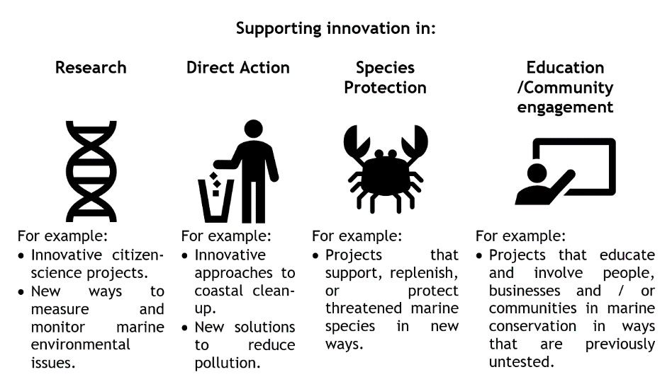
In 2021 a single Innovation Fund award of £2,000 was made. The project chosen is described here: https://www.sea-changers.org.uk/post/dorset-3deep-project-wins-our-first-innovation-grant-award. Their project used specialised software, stitching together hundreds of overlapping seabed photographs to create an otherwise impossible to see widescale “aerial” view of the Studland to Portland Special Area of Conservation (SAC), in Dorset. The view allows the monitoring of changes in fragile reef species within this area.

The Innovation Award also prompted two other grant awards funding a ‘blue carbon’ audit in Orkney run by Heriot Watt University and, the trial of the use of hydrophones attached to drifting buoys to monitor the presence of dolphins and porpoises and to record underwater soundscapes associated with different habitats run by Dorset Wildlife Trust.

Your project could be in the very early stages – e.g., developing a prototype or model. It could be that your idea is developed, but it needs piloting in order to gather evidence of its efficacy. It could also be an idea that, whilst tested other parts of the world, is a new solution for the UK marine environment and needs to be tested here.

The important thing about innovation is that there is learning from both successes and failures and we will therefore want to be sure that all grant applications explain how the success or failure of the project being applied for will be judged and measured.

Grant Award Sizes and Budgets
Sea-Changers envisages making between 3 and 15 grant awards from the 2022 Innovation Fund. The absolute maximum that can be applied for is £10,000 for any one project.
However, we consider it very unlikely that awards of this size will be made – the grants panel will be keen to maximise the number of projects being funded and will be balancing the quantity of awards that can be made against their quality. Sea-Changers recognises that by its very nature, innovation is risky and unpredictable in terms of impact and benefits. Given this, it is likely that the panel will want to spread the risk. We have a limited fund of £30,000 available and so, in essence, if you apply for £9,000, the panel will need to be convinced that your project is three times as likely to succeed, as a project requesting an award of £3,000. To be clear, awards of £5,000-£10,000 will need to be exceptionally compelling to be successful. Nevertheless, if you do have that confidence in the transformative nature of your project, we will definitely consider applications for these larger sums very carefully.

Applicants are free to, and indeed, are encouraged to submit differing budget scenarios, showing what could be achieved with grants of different sizes under the programme. The form encourages you to do this and below is an example of what an application budget might look like from a project wishing to undertake some innovative research which requires funding for boat hire and purchasing of equipment and software. They are applying for two possible amounts. The extra value that will be gained for the larger amount applied for would need also to be explained.
Item | If £5,000 - £10,000 is awarded | If £3,000 - £5,000 is awarded | If £2,000 - £3,000 is awarded
Boat hire (@£100 per day) | NA | £2,000 – 20 days | £1,000 – 10 days
Underwater hardware (lights, cameras, hydrophones) | NA | £2,000 – two locations | £1,000 – one location
Purchase of off the shelf software for data processing | NA | £870 | £870
Total |  | £4,870 | £2,870

- Who can apply?
Sea-Changers welcomes applications from a wide range of UK based organisations including: charities and ‘not-for-profit’ organisations, companies, schools, universities or students who are carrying out marine conservation related activities, and community groups.

- Evaluation criteria
The Innovation Fund applications will be judged against the following criteria:

Degree of innovation and creativity
How well has the applicant evidenced the innovative nature of their project?

Potential for impact on coastal and marine environments and / or species.
- How well does the application explain the potential/expected/hoped for impact on the coastal and marine environment and/or species and how significant is this impact?
- How well does the application explain how the success or failure of the proposed innovation will be judged and evaluated?
- How will learning be shared to maximise the potential benefits of the innovation?
Value for money
- How well justified are the sums proposed?
- Is the applicant’s budget clear and detailed?
- Is the project good value for money?
- How likely is this to act as a ‘seed’ for larger/wider scale replication?
Deliverability and Scalability
- Does the project have a comprehensive budget that details all areas of expenditure including where any additional funding costs will be met?
- Is the application convincing in terms of deliverability? Does it outline clear milestones and timescales?
- If the innovation is a success do applicants have plans for a bigger roll out? What are the plans and how viable do they appear? (have they identified possible funds/commercial potential?)

- What don’t we fund?​
- Projects that have a political aim.
- Applications solely to fund administrative or core operating costs.
- Retrospective projects or funding requests.
- Individuals or causes that will benefit only one person.

- The application and evaluation process
Applying
- Download and complete the Innovation Grant Fund Application Form from Sea-Changers’ website.
- Ensure you read through the guidelines above and that your application meets the outlined criteria.
- Complete and return the application form by email to info@sea-changers.org.uk
The timescales for the Innovation Fund 2022 are as follows:
- Deadline for receipt of applications – midnight on the 18th September 2022
- Announcement of outcomes and payments made – Mid November 2022
- Implementation – 2023. We expect projects to take from 6 to 12 months. If your project will take longer than that, we will need to be able to get at least some interim evaluation feedback 12 months after the grant is awarded.

Evaluation
All successful applicants would be asked to provide data and feedback on the outcomes achieved through the funding received, as a condition of receiving a grant.

We will send an evaluation form for you to complete but we would also ask that you consider in your application how you will evaluate your project at all stages of implementation.

​

Students should note that the grant award will need to be paid to your University / Education Institution, we cannot make personal payments to private individuals.

